Table identifying central key factors:

Importance (1-10) | Issue / Topic | positive aspects | negative aspects | Sources
Link to appearance | Anthropomorphism* | Motivated by:  - Accessibility  - Effective motivation  - Social motivation  People who perceive higher levels of anthropomorphism tend to be more positive in the general evaluation of a social robot, perceive higher enjoyment when engaging with it and are more likely to see the robot as a companion | - The more human-like a system acts, the broader the expectations that people may have for it  - ascribe implicitly mental capabilities to agents (that actually do not own), especially at the beginning, when agents responds correctly to user’s needs and commands  Uncanny valley: excessive similarity produces an abrupt descent of the sense of familiarity, until descend causing a sense of repulsion and disturbance in the user -> reduced realism inconsistency | (Guiot, 2019; Torresen, 2018)  Graaf, 2015
7 | Technology Acceptance Model | Factors that influencing adoption and trust:  - Ease of Use  - Perceived Usefulness  - zusätzlich bei Graaf  - hedonic factors of enjoyment  - anthropomorphism |  | (Guiot, 2019)
 | To increase trust | - Functional (complete required task)  - Helpful (provide guidance, help)  - Reliable (consistent and predictable) system |  | (Guiot, 2019, p. 120)
 | Increased biases |  | - Gender: stereotypical attribution of personality traits  - Culture: use female AI voice assistants
10  Societal aspects | Ethical challenges | - avoiding misuse and allowing for human inspection of the functionality of the algorithms and systems  - when moving toward advanced autonomous systems, the systems should themselves be able to do ethical decision making to reduce the risk of unwanted behavior  - systems should have mechanisms that automatically limit behavior, and also inform operators about the conditions deemed to require human review  - morality based decision-making becomes a part of artificial intelligence systems  Future risks:  - People may become unemployed because of automation.  - How much and in what way are we going to work with increased automation?  - Losing human skills due to technological excellence.  - Artificial intelligence can be used for destructive and unwanted tasks.  - Successful AI can lead to the extinction of mankind?  Today’s risks:  - vulnerable to hacking  - misused for criminal activities such as burglary  guidelines like:  - Safety. There must be mechanisms (or opportunities for an operator) to control and limit a robot’s autonomy. Security. There must be a password or other keys to avoid inappropriate and illegal use of a robot.  - Traceability. As with aircraft, robots should have a “black box” to record and document their own behavior (Winfield and Jirotka, 2017).  - Identifiability. Robots should have serial numbers and registration number similar to cars.  - Privacy policy. Software and hardware should be used to encrypt and password protect sensitive data that the robot needs to save. |  | (Torresen, 2018)  Nocentini, 2019  Graaf, 2015
 | Cultural adaption | The robot should be able to adjust parameters for different cultures |  | (Nocentini et al., 2019)
 | Legal aspect | No rules can be found  regulation for social robots to overcome the problem that social robots cannot operate in environments with people without a supervision of an operator |  | Nocentini, 2019
 | interpersonal distance |  |  | Nocentini, 2019
 | Empathy |  |  | Nocentini, 2019
+ Abilities of social robot | detection of emotional and cognitive state of the user | robots should be endowed with the capability to understand feelings, intentions, and beliefs of the user, which are not only directly expressed by the user, but that are also shaped by bodily cues (i.e., gaze, posture, facial expressions) and vocal cues (i.e., vocal tones and expressions)  In order for SIRs to be accepted as natural interaction partners, they need meaningful sophisticated social skills, such as the ability to recognize social context or the capability to exchange emotions. |  | Nocentini, 2019  (Shin & Choo, 2011)
+ Abilities of social robot – with limitations | Learning | automatically generate new robotic behaviors that the robot learns directly from the user  “rather than relying on an inbuilt fixed repertoire of social behaviours, a robot should be able to learn and adapt to the social manners, routines and personal preferences of the people it is living with” |  | Nocentini, 2019  (Leite et al., 2013)
 | novelty effect  vs.  mere-exposure effect | quickly wears off (around two months of use) and, after that, people lose interest and change their attitudes towards the robots  Yet, people’s perceptions of technologies are likely to change over time as they develop experiences with that technologies and their usage skills develop  The participants evaluated the robot more positively over time, which can be explained by the fact that people are willing to ignore the shortcomings of a technology because of factors such as habituation and familiarity |  | Leite, 2013  (de Graaf et al., 2015)
link anthropomorphism | Appearance | participants consider the robot’s appearance more relevant than functionality, especially in domestic robots  “anthropomorphism might raise false expectations regarding the cognitive and social abilities that the robot cannot fulfil”. This is especially true in longterm interactions, since it is more likely that these “flaws” become visible over time  While animal-inspired embodiments are well suited for health and therapy related scenarios, as they elicit care-taking behaviours from humans, functional embodiments are more appropriate for work environments or domestic settings, where the ways in which the robot can assist users are a major determinant.  Just as humans and other living beings differ from each other in terms of internal and external characteristics, social robots also have their autonomous individuality displayed through their design and behavioral configuration |  | Leite, 2013  Graaf, 2015
+ Abilities of social robot, link to learning | interaction | (1) routine behaviours: Greetings and farewells, or performing everyday tasks together  (2) strategic behaviours: relational communication (e.g., talking about the relationship or recalling past activities together), performing planned activities together and self-disclosure (revealing personal information as a mechanism to give and receive advice that increases trust and intimacy)  These mechanisms are important for keeping users interested in the interaction. |  | Leite, 2013
Link to detection of emotional and cognitive state of the user | display of emotions and other non-verbal behaviours | capacity to understand, adapt and respond more appropriately to the user’s affective and motivational states  some consider the awareness of the user’s affective state more important than the actual display of emotions by the robot |  | Leite, 2013
 | memory | ability to identify different users and call them by their names  memory will give users the impression of behavioural coherence and plausibility, and therefore it might positively influence the perception of intelligence and quality of the interaction with the robot |  | Leite, 2013
Societal aspects | decrease the burden on social and healthcare systems | Social robots are hypothesized to aid the elderly to live in their homes autonomously for longer and therefore to |  | Graaf, 2015
Societal aspects | extending life expectancies and improving health and quality of life | (1) letting elderly people live autonomously for longer in their own homes; (2) helping elderly people feel less lonely; and (3) helping elderly people to stay fit, thus improving their health |  | Graaf, 2015
 | perception by users | On the one hand, social robots can be perceived as utilitarian systems; they are able to perform tasks such as housekeeping.  On the other hand, social robots are recognized as hedonic systems; they offer sociable interaction opportunities to be able to build long-term relationships with their users  People seem to respond to robots in one of two ways: either humans love and nurture social robots and build relationships with them, or humans see social robots as artificial, as machines. |  | Graaf, 2015
10 | privacy | When robots enter the domestic environment, people can feel that they are being watched, i.e. perceiving the presence of the social robot  Another privacy aspect of robots lies in the possibility for robot to monitor, deliver messages, and remind people of things or the factor that robots could be integrated with other home-sensing and monitoring systems, e.g. smart homes  privacy invasion could also be sensed with a robot asking private questions or speaking of private matters when visitors are in the house |  | Graaf, 2015
10 | perceived behavior control | Especially the negative evaluation of privacy, trust and perceived behavior control resulted in discontinuance of the robot. |  | Graaf, 2015
10  see also section "Existing statistical models (highlight importance of single factors)" | Most influential variables | - acceptance of a social robot for domestic use increases when future users believe that they possess the necessary skills to use a social robot, when they perceive that having such a robot enhances their status, and when they anticipate that such a robot will provide more enjoyable interactions, behave less sociably, and cause fewer privacy concerns  - variables of enjoyment, privacy, status, and self-efficacy play a key role. |  | (de Graaf et al., 2019)

*attribution of human feelings, physical qualities and mental states to unanimated artefacts; humans tend to see their world as a reflection of themselves (Guiot, 2019, p. 115)

Further relevant articles – mixed ideas:
- Categorize social robot according to socially evocative, social interface, socially receptive, and sociable -> design of the robot increases in its ability to support the social model in more complex environments
  - Importance of social model, which is often applied to explain, understand, and predict behavior (Breazeal, 2003)
- Check presentation fidelity X interactivity with robot
  - Scenario texts / mock-ups are not well suited to assess emotional / affective attitudes and social aspects (Xu et al., 2015)
- Describe an integrated robotic system instead of an (semi-) autonomous robot, see Bahadori et al., 2003

Examples of existing robots:
Idea: Upgrade your social robot by modules like using your robot for specific task:
- Pepper
  - Care-assisting: https://dl.acm.org/doi/10.1145/3491102.3517435
- RoboCare: intelligent home of which a robot is an integrated part

- Multiple robots described in Heerink et al., 2010:
  - Companion type social robot:
    - Seal shaped Paro
    - Huggable
  - Service type social robot:
    - nursebot Pearl
    - Care-o-bot (Frauenhofer)
  - Screen agent
    - Laura

- 4 robots described in Lohse et al., 2008:
  - AIBO
  - iCat
  - Barthoc (Antropomorhpic)
  - BIRON

Emphasized aspects within existing scales:
- From Koverola et al., 2022
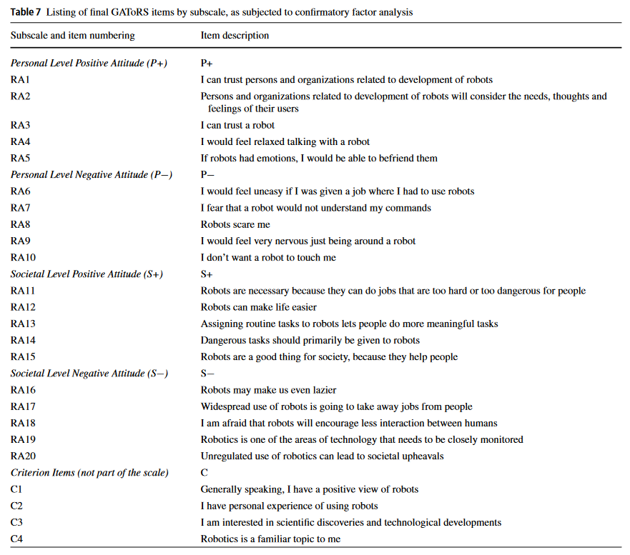
- From Peca et al., 2016

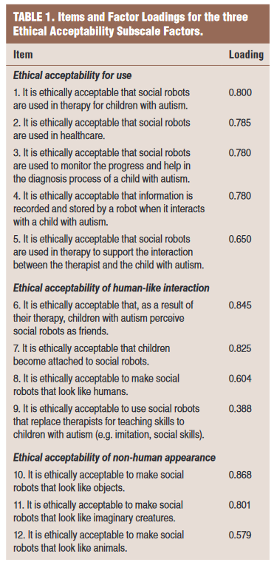
Existing statistical models (highlight importance of single factors):
- From Shin & Choo, 2011:

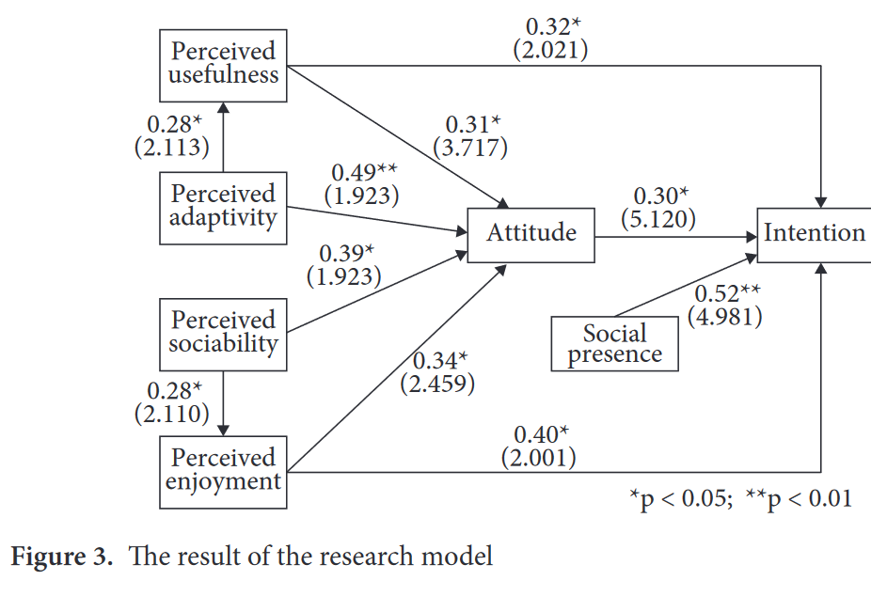
- From Heerink et al., 2010:
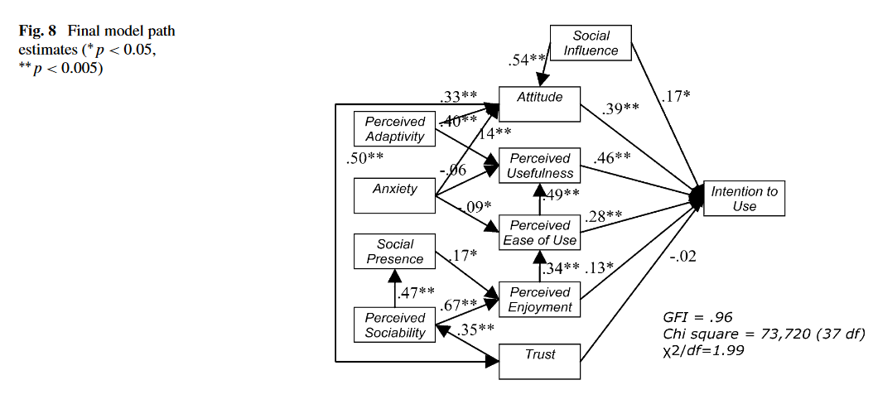

Ethical Principles in Social Robotics
(Coeckelbergh, 2021)
C. Bartneck et al., An Introduction to Ethics in Robotics and AI (2021, 28ff.):
- User acceptance and trust
- Beneficence
- Autonomy (as ability of the user to make decisions)
- Justice
- Explicability (i.e. intelligibility and accountability)

Isaac Asimov’s three rules of robotics (cit. Bartneck, 32):
- A robot may not injure a human being or, through inaction, allow a human being to come to harm.
- A robot must obey the orders given it by human beings except where such orders would conflict with the First Law.
- A robot must protect its own existence as long as such protection does not conflict with the First or Second Laws.

Literature
Bahadori, S., Cesta, A., Grisetti, G., Iocchi, L., Leone, R., Nardi, D., Oddi, A., Pecora, F., & Rasconi, R. (2003). RoboCare: An Integrated Robotic System for the Domestic Care of the Elderly (pp. 1–16).
Breazeal, C. (2003). Toward sociable robots. Robotics and Autonomous Systems, 42(3–4), 167–175. https://doi.org/10.1016/S0921-8890(02)00373-1
Coeckelbergh, M. (2021). Three Responses to Anthropomorphism in Social Robotics: Towards a Critical, Relational, and Hermeneutic Approach. International Journal of Social Robotics, 1–13. https://doi.org/10.1007/s12369-021-00770-0
de Graaf, M. M. A., Allouch, S. B., & Klamer, T. (2015). Sharing a life with Harvey: Exploring the acceptance of and relationship-building with a social robot. Computers in Human Behavior, 43, 1–14. https://doi.org/10.1016/j.chb.2014.10.030
de Graaf, M. M. A., Ben Allouch, S., & van Dijk, J. A. G. M. (2019). Why Would I Use This in My Home? A Model of Domestic Social Robot Acceptance. Human–Computer Interaction, 34(2), 115–173. https://doi.org/10.1080/07370024.2017.1312406
Guiot, V. (2019). Designing Trustworthy Agents. Politecnico di Milano.
Heerink, M., Kröse, B., Evers, V., & Wielinga, B. (2010). Assessing Acceptance of Assistive Social Agent Technology by Older Adults: The Almere Model. International Journal of Social Robotics, 2(4), 361–375. https://doi.org/10.1007/s12369-010-0068-5
Koverola, M., Kunnari, A., Sundvall, J., & Laakasuo, M. (2022). General Attitudes Towards Robots Scale (GAToRS): A New Instrument for Social Surveys. International Journal of Social Robotics. https://doi.org/10.1007/s12369-022-00880-3
Leite, I., Martinho, C., & Paiva, A. (2013). Social Robots for Long-Term Interaction: A Survey. International Journal of Social Robotics, 5(2), 291–308. https://doi.org/10.1007/s12369-013-0178-y
Lohse, M., Hegel, F., & Wrede, B. (2008). Domestic applications for social robots: An online survey on the influence of appearance and capabilities. Journal of Physical Agents (JoPha), 2(2), 21–32. https://doi.org/10.14198/JoPha.2008.2.2.04
Nocentini, O., Fiorini, L., Acerbi, G., Sorrentino, A., Mancioppi, G., & Cavallo, F. (2019). A Survey of Behavioral Models for Social Robots. Robotics, 8(3), 1–35. https://doi.org/10.3390/robotics8030054
Peca, A., Coeckelbergh, M., Simut, R., Costescu, C., Pintea, S., David, D., & Vanderborght, B. (2016). Robot Enhanced Therapy for Children with Autism Disorders: Measuring Ethical Acceptability. IEEE Technology and Society Magazine, 35(2), 54–66. https://doi.org/10.1109/MTS.2016.2554701
Shin, D.-H., & Choo, H. (2011). Modeling the acceptance of socially interactive robotics: Social presence in human–robot interaction. Interaction Studies. Social Behaviour and Communication in Biological and Artificial Systems, 12(3), 430–460. https://doi.org/10.1075/is.12.3.04shi
Torresen, J. (2018). A Review of Future and Ethical Perspectives of Robotics and AI. Frontiers in Robotics and AI, 4, 1–10.
Xu, Q., Ng, J., Tan, O., Huang, Z., Tay, B., & Park, T. (2015). Methodological Issues in Scenario-Based Evaluation of Human–Robot Interaction. International Journal of Social Robotics, 7(2), 279–291. https://doi.org/10.1007/s12369-014-0248-9

